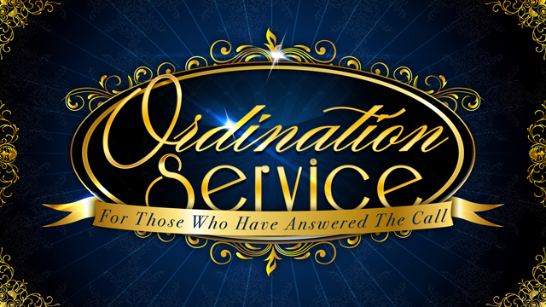
Jeremiah 3:15
Please join us for the Licensing & Ordination service of
Pastor Quincy & Prophetess Charlotte Millikin
New Visions of Life
129 E. Park Row Dr.
Arlington, TX. 76014

Date & Time: Saturday, October 26, 2013
@ 11:00am

